Homework for Week of March 14-18 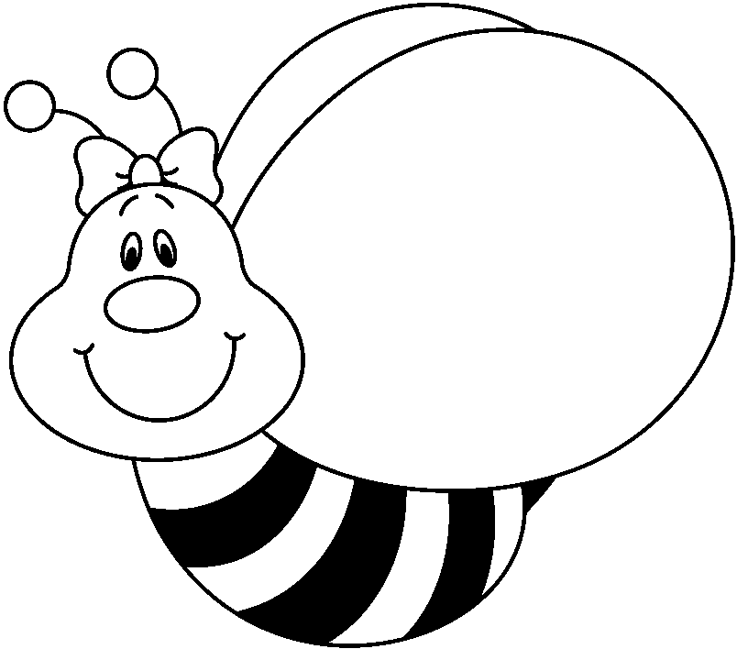

Monday-Practice Book p. 203, 204, 205, Math p. 392a/b, Work on Mammal Report

Tuesday-Practice Book p. 207, 208, Math p. 393-396, Work on Mammal Report

Wednesday-Practice Book p. 200-201, New Weekly Writing coming home. Math p. E 71, E 79

Work on Mammal Report

Thursday-Practice Book p. 194, 195, **Chapter 7 math test**, Work on Mammal Report

Friday-Spelling test, Wordly Wise Test Lesson 11

FYI

1. Monday is our day to go to the book fair. Students may bring money, but are responsible for its safekeeping. We are going after lunch. Don’t forget tax! There will be other opportunities to shop after school.
2. I have attached some enrichment pages here for Math chapter 7 for your use if desired. Two pages will be homework this week.
3. Don’t forget about Scootpad and Mickey’s Typing Club which are available to help hone skills.
4. It is extremely important the children read at home every day!
5. The Make A Difference Raffle continues as long as tickets are available.

Spelling- ea and ee

1. clean
2. keep
3. please
4. feel
5. we
6. be
7. eat
8. tree
9. mean
10. read
11. the
12. people
13. stream
14. steep