Homework March 7-11
Spelling for “Big Bushy Mustache” –focus ow, ou
1. town 2. house 3. sour 4. frown 5. cow
6. clown 7. found 8. how 9. mouse 10. brown . 11. could 12. should 13. around 14. towel

Monday-Do Reading Practice Book p. 176. Choose which mammal you are doing your report on. Math-TBA (to be announced)

Tuesday- Reading Practice Book p. 178-179. Start working on your mammal report. Math-TBA

Wednesday--Attached is the story of “Big Bushy Mustache”. Reread it tonight from the blog under H.M. Reading Links or take your book home. Write a summary on the paper provided in class. Reading Practice Book p. 190-191. Do verb paper. Work on mammal report. Math-TBA

Thursday-Practice Reading Book p. 186-187. Verb paper. Work on mammal report. Math-TBA
Friday-Spelling test. 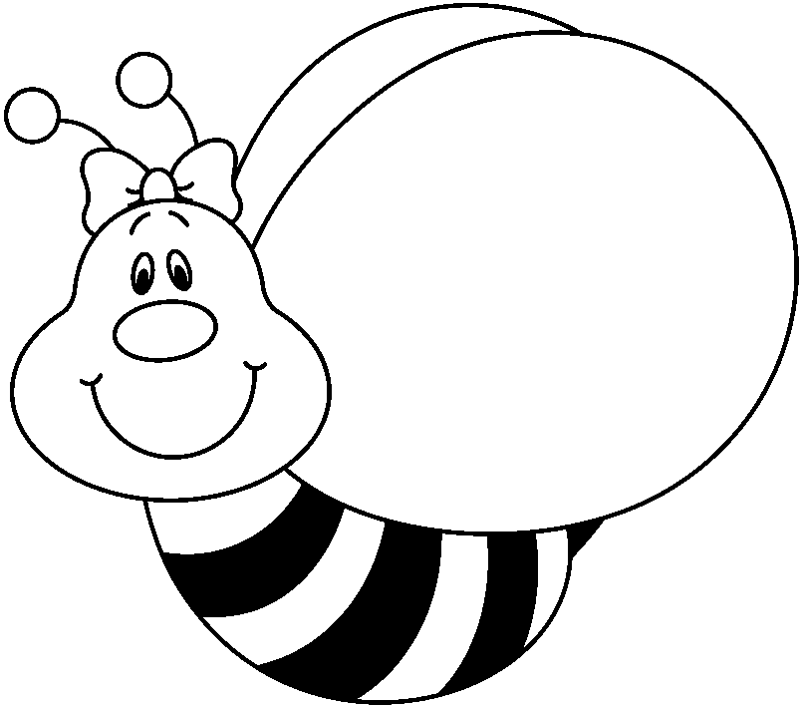

REMINDERS:
- This week is minimum day all week
- Read every night and write in your reading log
- Don’t forget that you have Scootpad and Mickey’s Typing Club to use to help sharpen your skills

