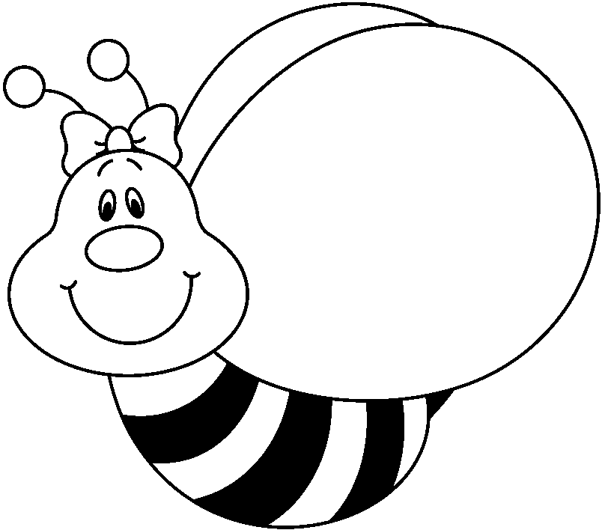

Homework for the week of Nov. 16-20

All this week is minimum days due to conferences. I have really enjoyed the conferences that I have had so far and am looking forward to the rest. I am putting the schedule on the back as a reminder. Other reminders are: Wednesday is our Harvest Festival from 11:30-12:30 and also the day for picture retakes or makeups. Friday is the last day before our Fall Break, which is November 23-27.
Don’t forget your library books on Monday!

Monday: Reading -Practice Book p. 67-70. Math p. 188 a/b (lesson 4.4)

Tuesday: Reading- Practice Book p. 73-74. Math p. 192 a/b (lesson 4.5)

Wednesday: Reading-Practice Book p. 75-77. Math p. 196 a/b (lesson 4.6)

Thursday: Reading-Practice Book p. 78-81. Math-none

Friday: Spelling Test
bone robe use these rope note

cute close hope those one goes

On Friday I will be asking the students about their progress on their Goods and Services project. I hope they will have chosen what they are doing and have started on their packets. We will begin filming on December 1.

Continue reading nightly and writing in your reading logs. Scootpad, Raz-kids, Mickey’s Typing Adventure, Birdbrain Science, and WriteReader are all available.

