Homework Week of April 11-15 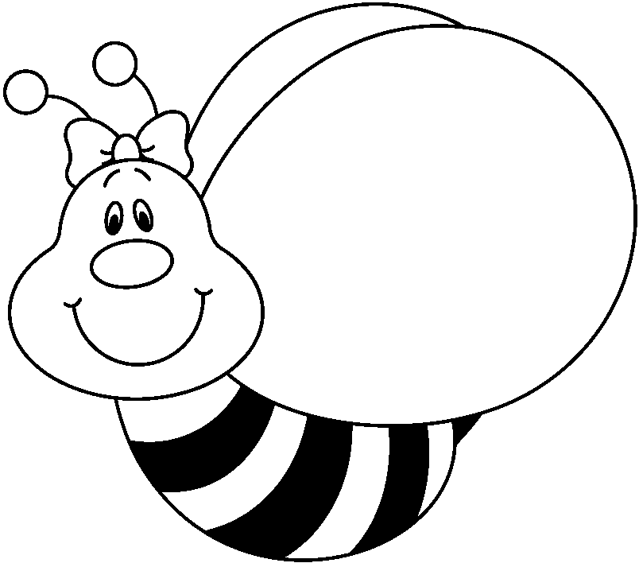
Spelling Words that end with -nd, ng, or nk

king thank hand sing send think

bring bang end thing and long

Monday-bring your library book! Your Weekly Writing #3 is due today. Do -tion and -ture worksheet. Using your Wordly Wise handout, answer the questions on the back. Math p. 428a/b

Tuesday-Do -tion and -ture worksheet. Write each of your Wordly Wise words in your own sentence on your own paper. Choose one meaning for each word. Underline the word. Math p. 432a/b

Wednesday-New Weekly Writing (#4) going home. Math p. 436a/b. Practice Book p. 16 and 17.

Thursday-Math is the practice math test for Chapter 8.

Friday-Chapter 8 math test, Spelling Test, Wordly Wise Lesson 12 test.
Things to Remember
Wednesday, April 13, is Spring Picture Day. Make sure your choice of background paper is in, if you want.

Field trip permission slip to Hiller Aviation is due by Friday, April 15.

Look over the End of Year Picnic Flyer and get it in as soon .as possible

