March 13-17 Homework

Monday-Spelling (parent gives pretest following directions on the sheet-parent signs and child returns it to school). L. Arts sheet. Math lesson 7.2. Poem.
Tuesday-Spelling. Mammal reports are due! Math lesson 7.3
Wednesday-Spelling. Math lesson 7.4. L. Arts sheet
Thursday-Spelling. Handwriting sheet. Math lesson 7.5. Oral presentations of mammal report start (see guidelines on the back)
Friday-Spelling test. Poem recitation. Reading logs.
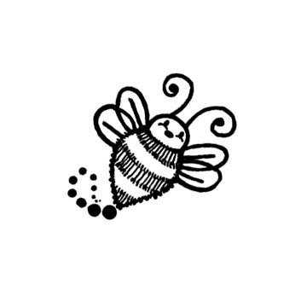
Important Dates and Reminders

*If you would like a chance to win some fantastic prizes and help our science lab, please purchase a "Make a Difference" raffle ticket!
*Book Fair is all week. Our class day to go is this Monday.

March 14-Students will have their kick off science fair assembly at 8:30. Information to go home.

March 23-Crazy hair day

April 7- Spring pictures

