May 2-6 Homework 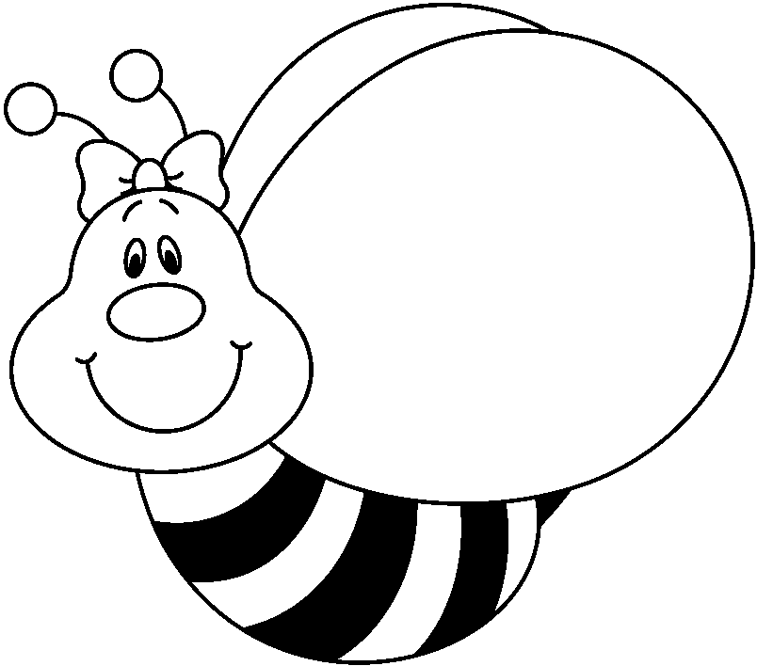

*No spelling this week. We will be starting Lesson 13 in Wordly Wise. The test will be next week.

Monday-Field trip to Hiller Aviation. Weekly Writing is due today. Bring your library book. (We may have time to return them today. There will be no more library check out this year. ) Handout on Amelia Earhart/Wright Brothers.

Tuesday-Math p. 484a/b, "The Great Ball Game"/Dictionary handout, cause and effect handout

Wednesday-Weekly writing goes home. Math p. 488a/b, cause and effect handout, using the dictionary handout

Thursday-Math p. 492a/b. Cause and effect handout
Important Dates

May 2-Reception for District Art Show, 6:30-8:00. Art show runs from May 2-May 25
May 6-Pennies for Patients reward. Dump ice water on Mrs. Nunez at flag.
May 8-Mother's Day
May 10-Science Fair Projects Due
May 12-Open House
May 30-Memorial Day
June 6-End of the year picnic

