May 9-13 Homework 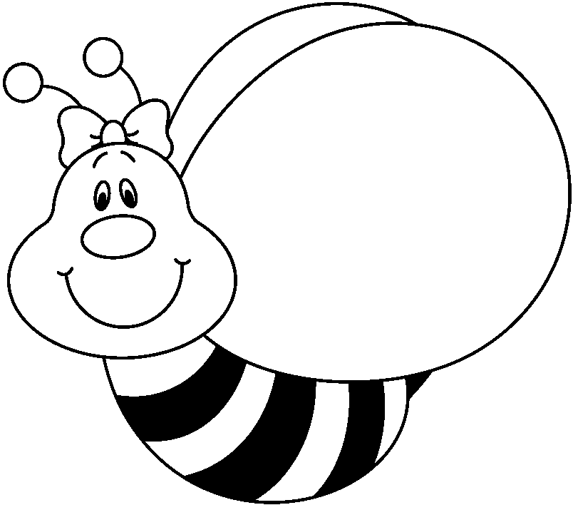

You have worked so hard on your science fair projects that we are going to have a fairly light week, although we will have a spelling, math, and Wordly Wise Test.
It turns out that we have one more week to check out library books. Bring your books to get a last chance to check one out!
Long "o" spelling
boat cold road blow gold old

load snow hold most toe do

Monday-Work on your science fair projects. Math 496a/b. Bring your Weekly Writing (it is the last one for this year!)

Tuesday-Science fair projects are due!! Math p. 500a/b

Wednesday-Chapter 10 review test

Thursday-Chapter 10 math test, plural possessives Practice Book p. 56, 57, 58

Friday-Spelling test, Wordly Wise Lesson 13 test
Important Dates
Tuesday, May 10-science fair projects are due
Thursday, May 12-Open house 5:30-6:30
Monday, May 30-Memorial Day-no school
Thursday, June 2-2nd & 3rd grade field day
Monday, June 6-Cataldi Park Picnic
Friday, June 10-Last day of school. 11:30 dismissal

