My Family History
A Two Week-long Homework Project
Mrs. Foster
Due on Friday, Sept. 26

One of our social studies unit is “Long Ago and Yesterday.” Students learn about the differences of life long ago and things that happened yesterday.
Family history is a meaningful part of who we are. It is important for your child to know and understand your family’s history. Please use this project to educate your child about your own history, the history of your parents, grandparents and beyond.
This will take the place of all homework except math for two weeks. There is an extra week if you count vacation time. I know the science projects are being completed too, but I think you will find this fun and not too time consuming

All students are required to complete this project which includes ALL of the following:

- An interview with a family member about family history using the attached form.

- Draw a family portrait and label family members. This can include sisters, brothers, parents, grandparents and whoever else is important in your family.

- Create a time-line of important events in your life. This can be done on the form provided or you could make your own.

- Label on the world map the country or countries your ancestors came from.

- Make a doll that displays your cultural dress. You can use the template I gave you or you can use your own. Instructions for each of these parts of the project follow.

- Staple or bind the first four pieces in a book form. Keep the cultural doll separate so that it can be displayed.
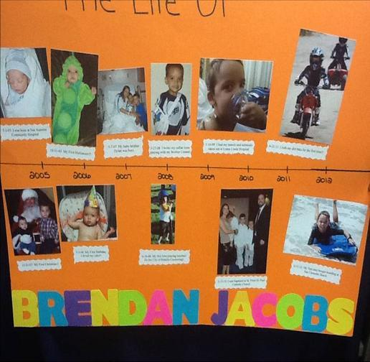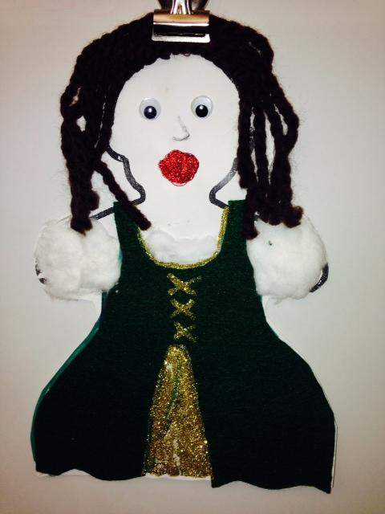

Timeline Example Ancestor Doll Example

Name

Interview with a relative.

I interviewed .

He/she is my .

Where were you born? .

What are some of the things you did as a child?

How was your life then different from mine today?

Do you have anything from when you were a child to show me?

(Draw a picture of the artifact and label what it is.)
Instructions for Cultural Doll
Cut out one of the forms attached, trace it on heavy paper, or make your own, Dress your doll in a costume that represents your culture. If you have more than one cultural background, choose just one to concentrate on. You can go to the library or look it up on the internet. Find a good picture of a cultural costume and dress your doll like that costume. You can use any materials you would like including crayons, markers, fabric, colored or folded paper, yarn, buttons, and whatever else you can find.

