October 24-28 Homework

We will be having a spelling review test on 36 phonetically based words from our reading theme "Silly Stories" on November 2.

Monday-Start memorizing your poem. It is best to practice a little bit every day. Hand in poem and handwriting on Friday. Language arts paper. Math handout. Library books due.

Tuesday-Practice Book p. 54, 55, 56. Math handout

Wednesday- Language arts paper Math handout

Thursday- Practice Book p. 61, 62, 63. Math handout

Friday-Reading logs due. Field trip to Prusch Farms. Pack a lunch and wear your class t-shirt.
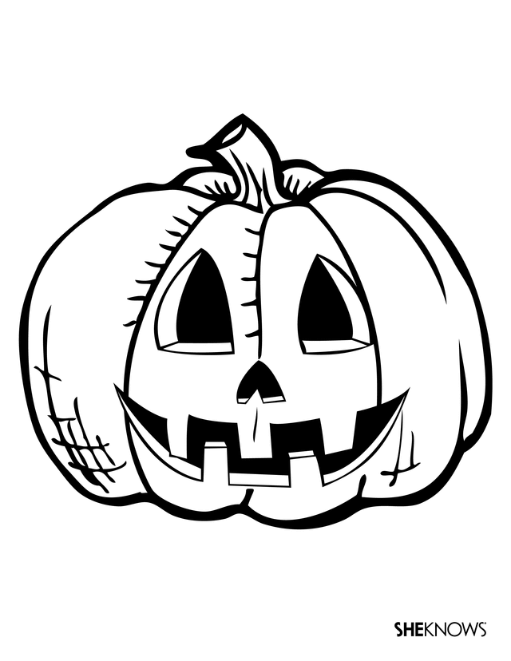
*Important Dates*
Oct. 28-Prusch Farms field trip; leaving at 10:45, back @ 1:00
Oct. 31-Halloween Party 1:00-2:00
parade in morning, time TBA
Nov. 11-Veteran's Day, no school
Nov. 14-Fall conferences begin
Nov. 16-Aladdin trip. Information coming
Nov. 21-25-Thanksgiving Break

